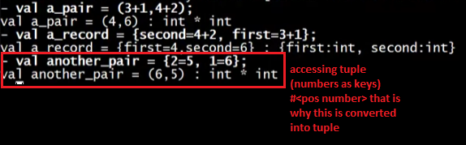

Using numbers as keys/fields



* Case: counting numbers not complete (skipped 2)
* Will return a record

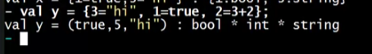

* Case: counting numbers complete, no skipping
* Will return a triple (tuple with 3 elements)

Important note:

* There is no such thing as tuples in ML, there are only records and tuples are just a way, a different way of writing records that you as a programmer can use whenever you want. And the REPL always chooses to use of it as it can and this is because tuples are just "syntactic sugar" for records.

